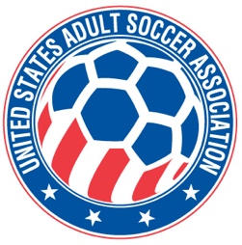

**USASA National Board of Directors (NBOD) Meeting Recap**

**Date:**  Wednesday, March 12, 7:00 p.m. CDT vial Zoom

**Action Items and Key Notes from the NBOD Meeting**

1. NEW BOARD MEMBER WELCOMED. Vincent Treglia was welcomed to the National Board of Directors for his first meeting since being elected.
2. MEMBER REGISTRATION AND DATA SUBMISSION. We are early in the year so player registrations are just starting to come in. We are a bit ahead of where we were last year at this time. The official policy deadline for player registrations and data is April 15th for the first quarter. Annual membership affiliation fees have been received from most members. There are ten outstanding but all have indicated their payment is being sent.
3. NATIONAL CUPS. The National Cups Committee is working on a rotation of the finals location across the regions beginning in 2026. Requests for bids proposals are going to be sent out. There are budget matters to resolve because the Over 30s and 40s are being included in the finals event this year but the approved budget was not presented with that as an assumption. There is a budget line for Over 30s and 40s which will be included in the final overall budget for 2025.
4. COMMITTEE APPOINTMENTS. The Referee Committee appointments were recommended by Jim. The two additional members of the committee are Rachel Woo and Juan Guzman.
5. WIGs and Collective Global. A recommendation will be presented at the next board meeting regarding the project plans and timelines coming from the Working Group sub-goals. A proposal for additional work by The Collective Global has been received and will be considered at the next meeting. The work would continue assistance with the staff and board to move us into the execution phase of our planning.
6. NEXT NBOD MEETING. The next meeting will be **Wednesday, April 2d at 7pm CDT via Zoom.**