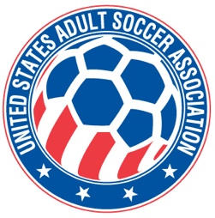

**USASA National Board of Directors (NBOD) Meeting Recap**

**Date:**  Wednesday, April 2, 7:00 p.m. CDT vial Zoom

**Action Items and Key Notes from the NBOD Meeting**

1. ONE-ON-ONE MEMBERS MEETINGS WITH JIM. Meetings with members continue and represent close to half of member organizations.
2. MEMBER REGISTRATION. Player registration numbers are trending ahead of last year as of March 31st; we are 48% of 2024. April regularly is a bigger month as it is the deadline for reporting first quarter registrations and submitting data.
3. INSURANCE PERFORMANCE REVIEW. Bruce presented a report on the performance of our Player Accident Insurance. In general, our losses are at an acceptable level. Over the past four years we have paid nearly $2 million on players’ claims.
4. USSF POLICY 531-9. There was a discussion about the implementation of the revised US Soccer Policy 531-9 related to referee abuse prevention and it’s impact on state associations and member leagues. There is additional guidance from US Soccer expected and needed. A desire for more information and direction for our member organization was expressed.
5. WIGs and Collective Global. Bruce presented the report outlining the next phase of implementing our WIGs. A description of projects and deliverables were reviewed. Detailed project plans are being completed for the initiatives described in the report. The next phase is executing on the identified priorities. A decision to engage The Collective Global for assistance with the execution phase was approved for the second quarter of 2025.
6. NEXT NBOD MEETING. The next meeting will be **Wednesday, May 7th at 7pm CDT via Zoom.**