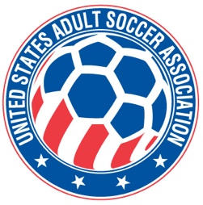

**USASA National Board of Directors (NBOD) Meeting Recap**

**Date:**  Wednesday, June 4, 7:00 p.m. CDT via Zoom

**Action Items and Key Notes from the NBOD Meeting**

1. MEMBER REGISTRATION. Player registration numbers higher than this time last year. Current player registration numbers are 34% ahead of a year ago.
2. US COLLEGE CLUB SOCCER PROPOSAL. The proposal was introduced at the May meeting for US College Club Soccer to affiliate with specific terms under a two year agreement. The proposal was approved by the NBOD with certain defined terms to be further defined and agreed upon.
3. VETERANS CUP EMERGENCY ACTION PLAN. A recommendation for inclusion in the Emergency Action Plan for Veterans Cup was made by Bruce. It was recommended that a dedicated EMS/EMT not be required on-site for the entirety of the tournament. This was approved by the NBOD.
4. WIGs and Collective Global. The Collective Global next phase includes interviews and a follow-up survey of NBOD members. Those results will be shared with the board as part of the work with the NBOD on improving board function. Working Groups have begun their role in the implementation and execution phase of the WIGs. WIG subgoals and projects identified following the Atlanta meeting are underway and on track. Public reporting of progress is slightly behind. It will be caught up and published on the website shortly.
5. VETERANS CUP and AMATEUR CUP. Cezar Wasecki and Dan Trainor reported on each event. Both events are on track. Veterans Cup begins July 9th in Traverse City, Michigan. National Amateur Cup is ongoing at the regional level. The National finals will be July 25-26th in Milwaukee, Wisconsin.
6. NEXT NBOD MEETING. The next meeting will be **Wednesday, July 2nd at 7pm CDT via Zoom.**