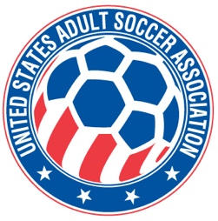

**USASA National Board of Directors (NBOD) Meeting Recap**

**Date:**  Wednesday, August 6, 7:00 p.m. CDT via Zoom

**Action Items and Key Notes from the NBOD Meeting**

1. NATIONAL AMATEUR CUP. The NBOD adopted the National Cups Committee recommendation that the 2026 National Amateur Cup finals take place in Milwaukee, Wisconsin at Uehlein Soccer Park on July 24-26.
2. NATIONAL OVER 30 AND OVER 40 COMPETITIONS. The board adopted a policy change that Over 30 and Over 40 national competitions will not be National Cups. This does not mean that these competitions will not occur. They simply will not be National Cups like the National Amateur Cup for men and women.
3. WIGs AND COLLECTIVE GLOBAL. The NBOD will meet with The Collective Global for three one-hour virtual sessions beginning next week as part of the ongoing strategic planning and development program. The staff is adjusting key priorities based on NBOD discussions at the NBOD In Person Retreat.
4. SOUTHWEST PREMIER LEAGUE MEMBERSHIP. The Southwest Premier League was approved for provisional membership as a USASA Multi-State league. The membership status will be reviewed after the start of their Spring 2026 season.
5. MEMBER REGISTRATION. Player registration numbers are a bit lower than this time last year. Total numbers are down 18% year over year. However, submission of player registration data has improved.
6. 2026 BUDGET FORUM. There will be two webinars presenting the draft 2026 Budget for members to attend in August. The webinar dates are: August 21st at 9pm CDT and August 24th at 7p CDT. The Zoom link can be found in the Member Portal or in the webinar announcement elsewhere in this newsletter. The dates will also be published on our website.
7. NBOD MEETING SCHEDULE. The board approved changing its regular business meetings to quarterly. Monthly Membership Meetings will continue. More about the change will be discussed at the AGM. This change takes place going forward.

NEXT MEMBERSHIP MEETING. The next meeting will be **Wednesday, September 10th at 7pm CDT via Zoom. The link will be posted on the USASA website.**