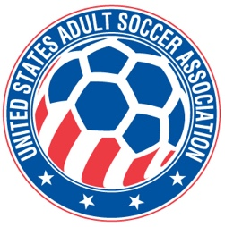

USASA National Board of Directors (NBOD) Meeting Recap
Date: Wednesday, December 10, 6:30 p.m. CST via Zoom
Action Items and Key Notes from the NBOD Meeting

- OPERATING RESERVE POLICY. The NBOD adopted the Budget & Finance Committee revised Operating Reserve Policy. The policy establishes amounts and procedures for an Operating Reserve fund for the organization. Policy Section

- INSURANCE RESERVE POLICY. The board sent back to the Budget & Finance Committee a revised Insurance Reserve Policy for further revisions.

- MAJOR ARENA SOCCER LEAGUE MEMBERSHIP. The Major Arena Soccer League was approved for as a USASA Multi-State league for its amateur divisions, MASL2, MASL3 and MASLW.

- MEMBER REGISTRATION. Player registration numbers are nearly exactly where they were this time last year. Submission of player registration data has improved this year. Those member organizations that have not submitted data have been notified at least twice. Additional communication to those members will be forthcoming.

- SPONSORSHIP AGENCY CONTRACT. A contract with SSEC for sponsorship work on behalf of USASA was approved. The agency will begin work starting on January 1st.

- NATIONAL AMATEUR CUP POLICY. Revisions to the National Amateur Cup policies recommended by the National Cups Committee were approved.

- WORKING GROUP #4 COMMITTEE RECOMMENDATIONS. Recommendations from WIG Working Group #4, Revamping the Operating Model, were introduced to the NBOD. The recommendations related to committee operations and structure. The board will review and consider the recommendations at the next meeting.

- PLAYER MEMBER NEWSLETTER. The inaugural Player Member Newsletter will be published before the holidays. The newsletter will be sent to all player members and member organization leadership.

NEXT NBOD MEETING. The next meeting will be Thursday, February 19th at the US Soccer AGM in Atlanta. Once confirmed, the time and location will be posted on the USASA website.

