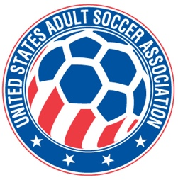

USASA National Board of Directors (NBOD) Meeting Recap
Date: Thursday, February 19, 3:00 p.m. EST, Atlanta, GA
Action Items and Key Notes from the NBOD Meeting

- MEMBER REGISTRATION. Final Player Registration numbers for 2025 were 216,278, down 6% from 2024. All members that submitted player registrations have submitted player data as well.

- NATIONAL AMATEUR CUP PROPOSAL. The proposal to request US Soccer take over administration and operations of the National Amateur Cup was discussed. The NBOD approved of the proposal. The matter was set for discussion and ratification by the USASA National Council at the meeting on February 20, 2025. The proposal was discussed by organization members attending the meeting via questions to the board.

- COMMITTEE MEMBER APPROVED. Jim Walker was APPROVED as a new member to the Appeals Committee without objection.

NEXT NBOD MEETING The next meeting time has not yet been confirmed. Once it is, the time and location will be posted on the USASA website and included in our newsletter.

